Experiment 5
AIM: Create a Web Page for Student Registration Form with Email Validation by applying form attributes (method, action, placeholder, required).
Objectives
1. To design a student registration form using HTML.
2. To apply form attributes: • method → Defines how data is sent. • action → Defines where data is sent. • placeholder → Displays hint text. • required → Ensures mandatory fields are filled.
3. To implement basic email validation using the type="email" attribute.
Tools Required
• Text Editor (Notepad, VS Code, Sublime Text)
• Web Browser (Chrome, Edge, Firefox)

Code implementation:
<!DOCTYPE html>
<html lang="en">
<head>
<meta charset="UTF-8">
<meta name="viewport" content="width=device-width, initial-scale=1.0">
<title>Course Curriculum</title>
</head>
<body>
<!-- This HTML document outlines the curriculum for the CSE-12 course -->
<h1>Course Curriculum:</h1>
<h5>CSE-12:Aditya gola</h5>
<!-- Introduction Section -->
<p>
Welcome to the <b>CSE-12</b> course curriculum. This course covers <i>fundamental concepts</i> in computer science.<br>
<u>Note:</u> Please review all topics carefully &amp; complete assignments on time.<br>
</p>
<!-- Course Objectives and Modules -->
<h2>Course Objectives &lt;Goals&gt;</h2>
<ul>
<li>Understand basic programming concepts</li>
<li>Learn about data structures</li>
<li>Explore algorithms</li>
<li>Develop problem-solving skills</li>
</ul>
<!-- Nested List Example -->
<h2>Course Modules</h2>
<ol>
<li>
Introduction
<ul>
<li>History of Computing</li>
<li>Applications &amp; Impact</li>
</ul>
</li>
<li>
Programming Basics
<ul>
<li>Variables</li>
<li>Operators</li>
<li>Control Structures</li>
</ul>
</li>
<li>
Data Structures
<ol>
<li>Arrays</li>
<li>Linked Lists</li>
<li>Stacks &amp; Queues</li>
</ol>
</li>
<li>
Algorithms
<ul>
<li>Sorting</li>
<li>Searching</li>
</ul>
</li>
</ol>
<!-- Definition List Example -->
<h2>Grading Policy</h2>
<dl>
<dt>Assignments</dt>
<dd>Weekly tasks to reinforce concepts</dd>
<dt>Quizzes</dt>
<dd>Short tests after each module</dd>
<dt>Final Exam</dt>
<dd>Comprehensive assessment at the end</dd>
</dl>
<!-- Mixed and Nested Lists Example -->
<h2>Mixed &amp; Nested Lists Example</h2>
<ul>
<li>Resources
<ol>
<li>Textbook</li>
<li>Online Tutorials</li>
</ol>
</li>
<li>Support
<ul>
<li>Discussion Forum</li>
<li>Email</li>
</ul>
</li>
</ul>
<!-- Footer Section -->
<p>
For more information, contact the instructor at <b>cse12&#64;university.edu</b>.
</p>
<hr>
<p>
&copy; 2025 CSE-12 Department
</p>
<!-- End of Document -->
</body>
</html>

OUTPUT: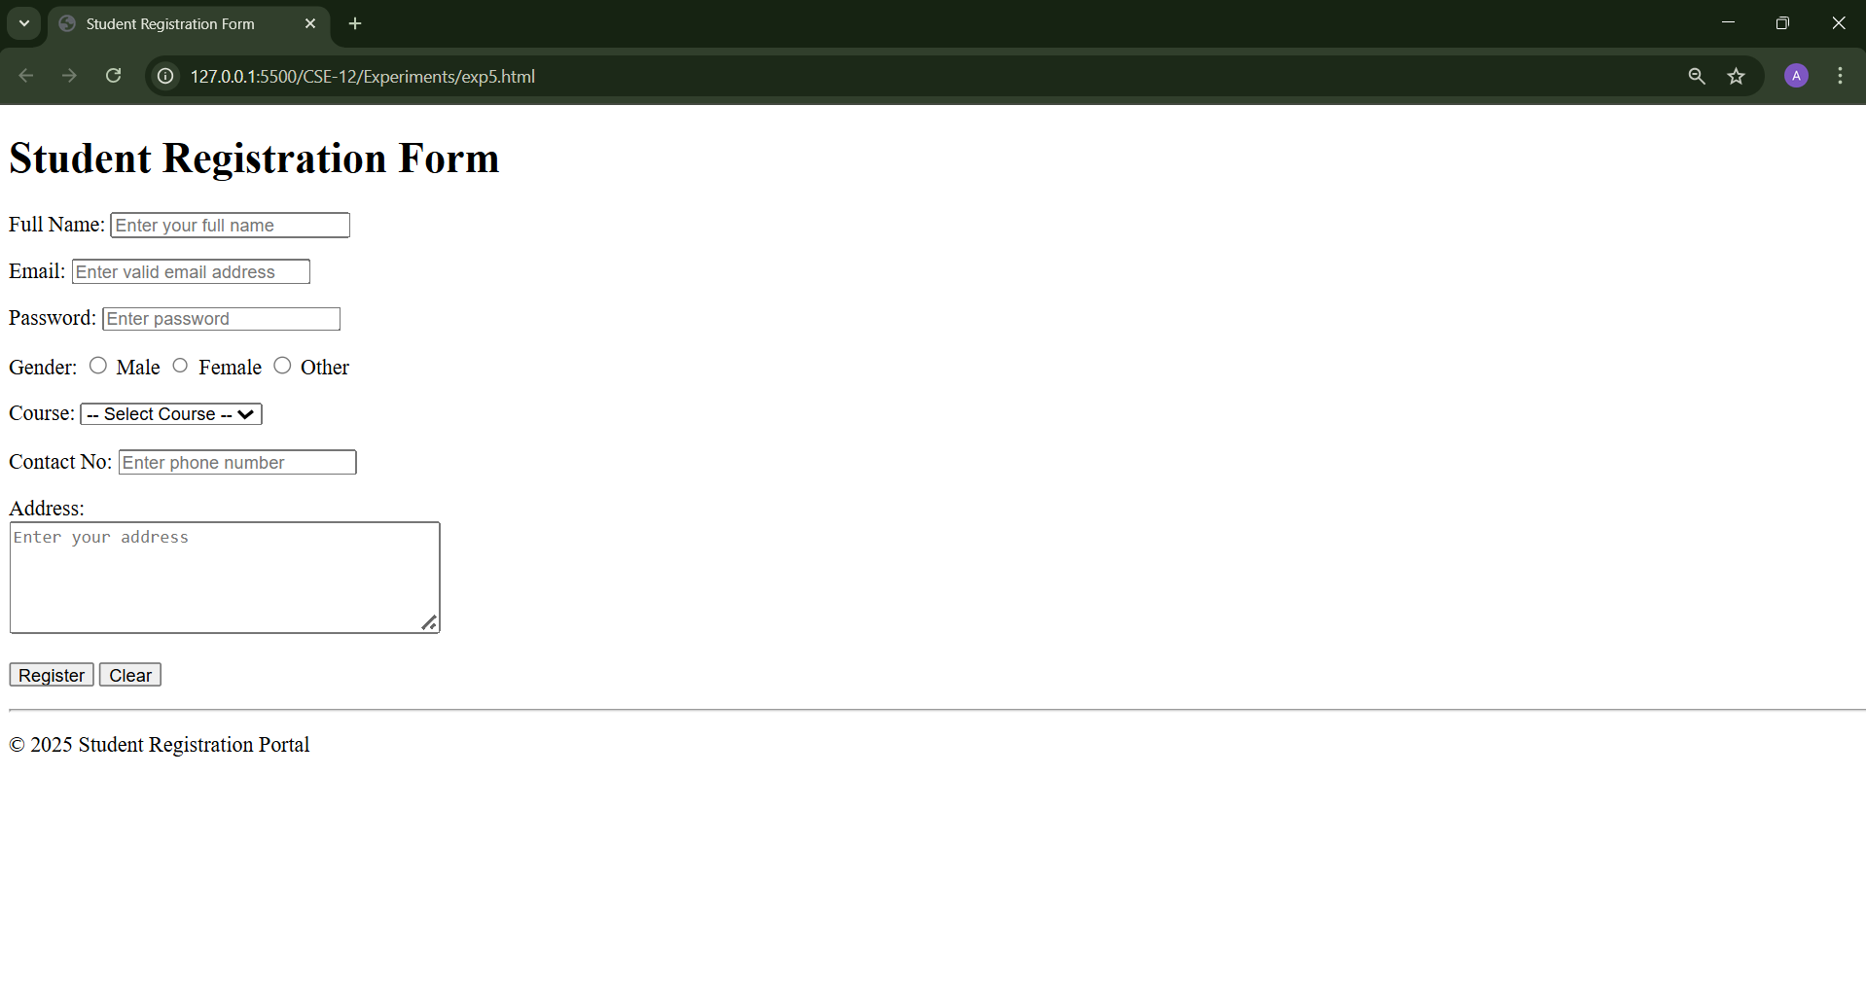
OUTCOME:
• Successfully created a Student Registration Form using only HTML.
• Applied form attributes: method, action, placeholder, required.
• Implemented email validation using type="email".
• Learned to design a structured form without CSS.

